Sales Operations and Tasks

Quick Tip: Press CTRL + F and type in what you are looking for in the search bar. (for example: type “Appraisal”)

Sending Documents for e-sign iTel / Repair Attempt
  - Task Brandon Pernot (operations assistant) during Business Hours
  - Reach out to and/or Task Danny or Brandon Pernot after Business Hours
  - If sending Itel or Repair Attempt, must have:
    - Current partial estimate
    - Photos
  - (see the section titled: Creating iTel, Repair Attempt, and Tarp Agreements below)
Once Customer signs iTel / RA Agreement - Tag Brandon Pernot and he will create Task to get a Field Technician scheduled
- Customer needs Tarp
  - Create Tarp Agreement and have customer sign (see the section titled: Creating iTel, Repair Attempt, and Tarp Agreements below)
  - Collect payment from customer
    - If check/cash - bring it to the office
    - If credit card - Task Ford to send qb link to customer for tarp payment
  - Tag Reese once customer has signed and you received payment
    - We will create task to get FT scheduled for tarp
Need a Repair Estimate
  - Task Danny

Requesting a job to be reviewed or to go to Appraisal or Public Adjuster
  - Message (Not Task) Reese on the job you would like reviewed
- Requesting a job be reviewed to go to TAG Reese on the job you would like reviewed
- If you believe a job is dead
  - Tag Reese on the message board for the job
- If you need a customer job file to be created in the Field Portal
  - You must have the following:
    - Full name
    - Email
    - Address
    - Phone Number
    - TH/SFH
  - Task Brandon Pernot
- If you have production/operations related questions
  - Task and Tag Ford
- If you need a job reviewed for Retail/Insurance Conversion
  - TAG Reese on the message board and he will create the proper task for Ford
- If you have general questions about estimates, denials, partials, reinspect, or any job stage before install
  - Tag Reese, Danny, and/or Brandon Pernot
- If you need immediate assistance to answer a customer’s questions about product, warranty, pricing, etc and you are unsure how to answer
  - In a group text, text Ford, Reese, and Oliver the question, one of them should be able to get to you quickly
  - If 1 minute passes and you do not have an answer Call Ford, Reese, Oliver, PC’s, or Trainers
- Full Approvals must have
  - Photos
  - Hover
  - If you submit estimate to Amber and do not have photos and hover yet, she will not move forward with Project Review
    - Once you upload photos/hover, Tag Amber to let her know

- Pinning Homes
  - You should pin every home that you knock
  - Under the Leads page of the Field Portal App on your phone, you will press the arrow at the top right of the screen to pull up the map
  - Here, you will long press on a home and then fill out the information you have
  - Status is the only required field (it is a drop down menu)
  - See screenshots below
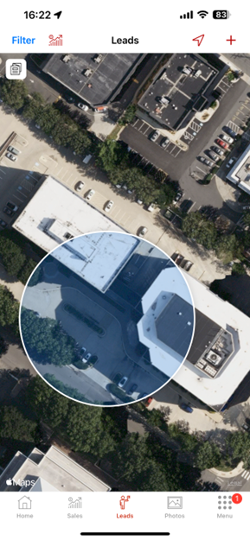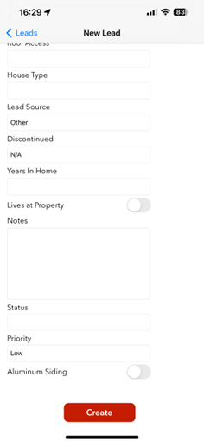

- Signing up a new customer
  - Enter all required fields on Sales App using the iPad
  - After HO files claim, enter Claim Number
  - Press Proceed to Agreement ONCE ONLY (if nothing happens, wait at least a minute before attempting to press it again - simply because nothing happens immediately, it does not mean that you did not press the button, the system is just moving slow)
  - You sign Contingency Agreement
    - For roof and aluminum siding sign up, write “Full replacement value claim = Full approval for roof and/or siding”
  - HO signs Contingency Agreement and Claim Authorization
  - Press Submit
  - Enter password roofer if applicable
- Signing up a lead
  - When a lead is already in your portal under Inspection Pending
    - DO NOT type in all the HO’s information again
    - Press the red letters at the top of the screen that says LEADS
    - Then you select your customer’s name
  - After HO files claim, enter Claim Number
  - Press Proceed to Agreement ONCE ONLY (if nothing happens, wait at least a minute before attempting to press it again - a lot of people think they must not have pressed it, which is why it did not go through, but usually it is not the case, the system is just moving slow)
  - You sign Contingency Agreement
    - For roof and aluminum siding sign up, write “Full replacement value claim = Full approval for roof and/or siding”
  - HO signs Contingency Agreement and Claim Authorization
  - Press Submit
  - Enter password roofer if applicable
  - See screenshot below
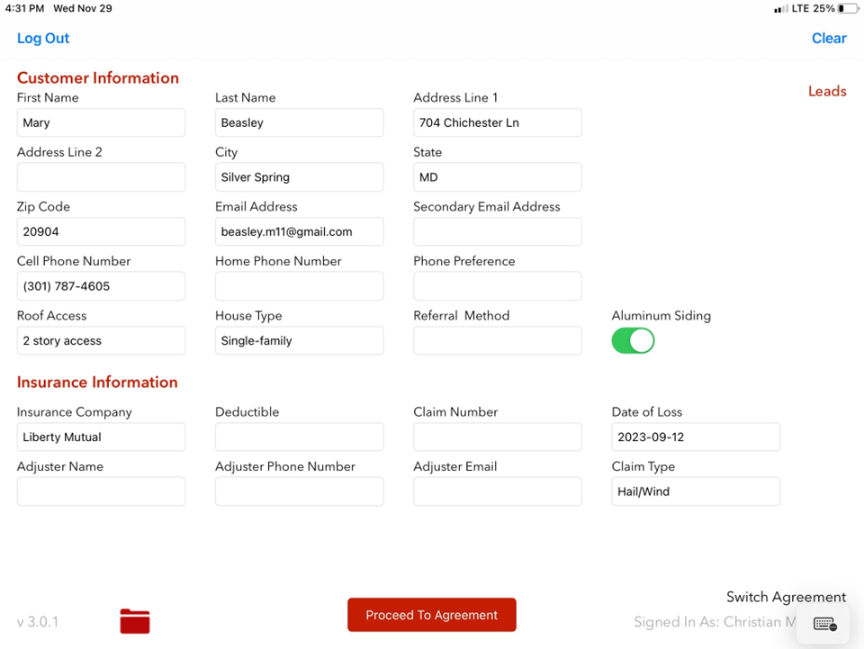

- Creating iTel, Repair Attempt, or Tarp Agreements
  - Click the words Switch Agreement at the bottom right of the screen
  - Select needed agreement (Itel, Repair Attempt, or Tarp)
  - DO NOT enter in the customer’s information again
    - Press Existing Customers at the top right of the screen
    - Fill out additional information at the bottom of the page
      - Please reach out to Reese, Danny, or your trainer if you need additional assistance with this bottom section
    - Press Proceed to Agreement
    - You sign Agreement
    - Customer signs Agreement
    - For iTel and Repair Attempt make sure to let HO know that they are never responsible for the cost that appears on the agreement (read the bold section of the agreement)
    - For Tarp make sure to let HO know to submit payment first, but they will be reimbursed by the insurance company
      - See section above titled: “Customer needs Tarp”
- Uploading Missing Documents
  - If you notice that the job file for your customer is missing Contingency or Claim Authorization do the following:
    - Open the Sales App
    - Click the documents button (folder) at the bottom left of the screen
    - Scroll until you see your customer
    - Press the upload button next to each of the forms that you need uploaded (button looks like a cloud with an up arrow inside of it)

- Filming Repair Attempt Video
- Before you begin filming, ask the Field Tech (Francisco or Ishmael) to point out which of the surrounding shingles will be affected by the extraction. Mark the damaged tab (if applicable) and mark the bottom right corner with chalk of every shingle the Field Tech points out.
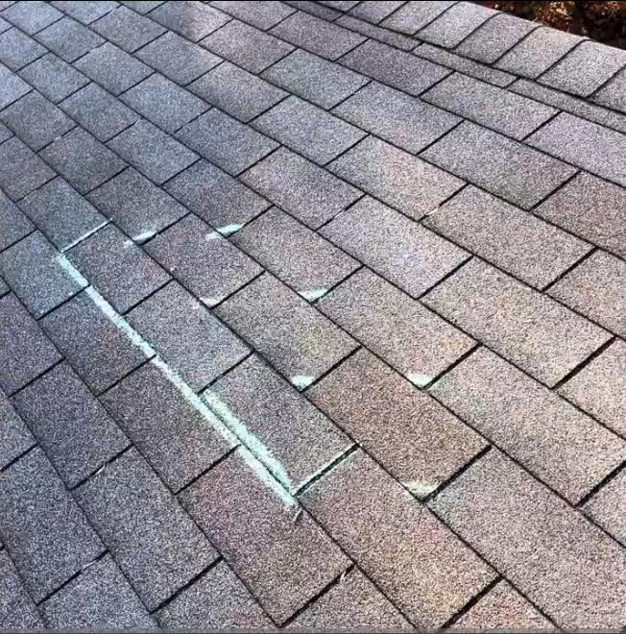

- Before you begin filming; take a before shot of the area where you will be extracting the shingle. Start recording, “...Here we are at [HOMEOWNER’S HOUSE] performing a repair attempt on this storm damaged shingle. As you can see I have pre-marked every tab that will sustain unavoidable creasing due to the brittleness of the roof. Go ahead and get started Francisco/Ishmael”

- Film the entire area where repair is going to occur, then go from the Wide camera shot to a low down side view camera angle, to show how the shingles get bent back/pried up during the process. Make sure to show on camera or explicitly mention the high amount of granule loss running down the roof.
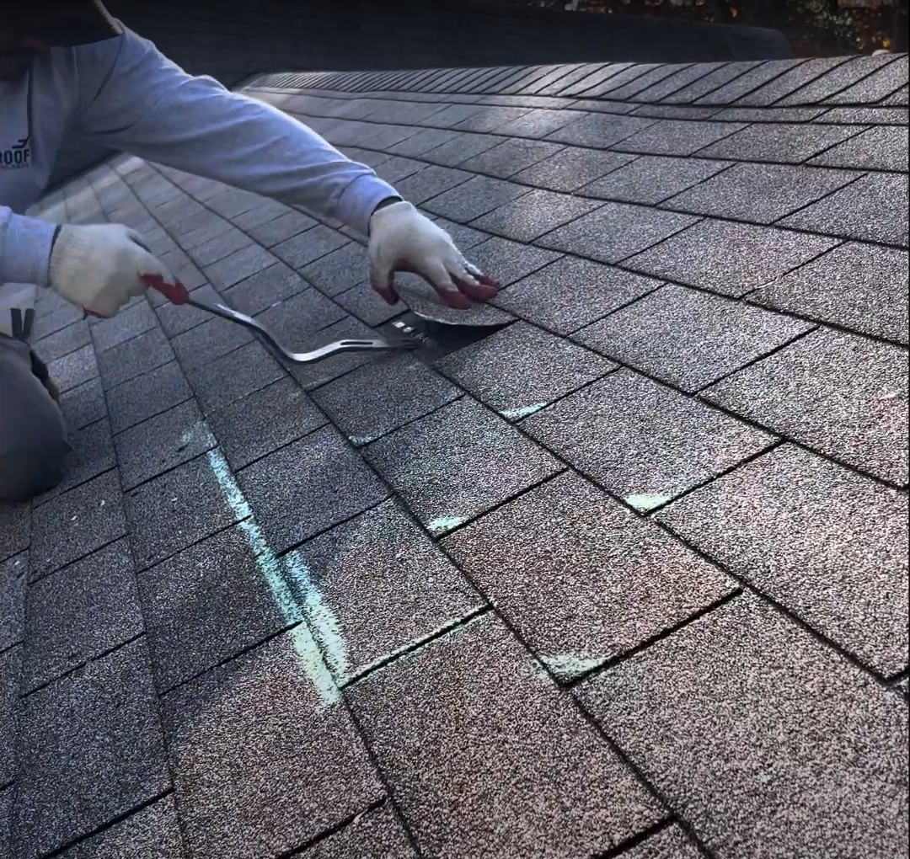

- Once the new shingle has been installed, hover the camera over the shingles and wipe your hand back and forth gently over the top of each tab that was pried up. Trace your finger along the crease and show it on camera, explain how each tab has now been mechanically creased and confirms the roof failed a “brittle test”.

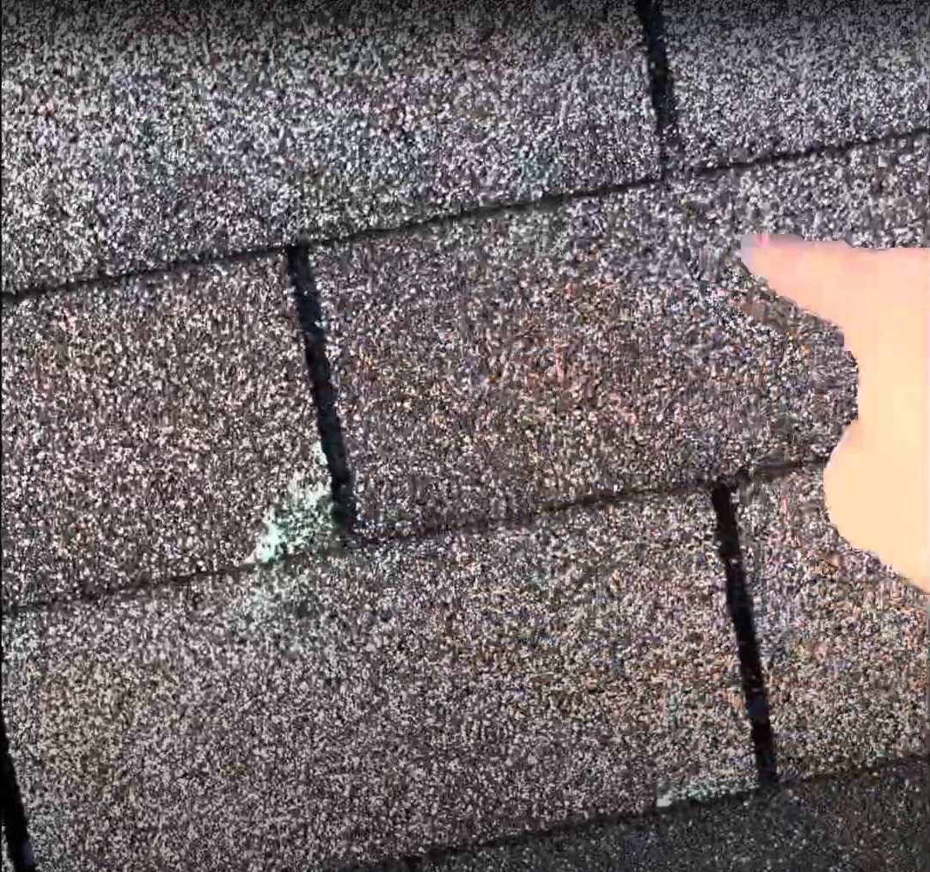

- Once you have finished recording your video. Take close-up after pictures of the browns above the replaced shingle. Draw an arrow to where the crease is on the shingle or point to it for the picture.

Checklist for Post-Adjuster Meeting
- Photo Report Complete
  - Upload photo report from photos tab when you have good reception
- Hover Complete
- Move Job File
  - Most jobs should go to Estimate Pending (make sure to look at next item on this check list - very important when moving a job to Estimate Pending)
  - Jobs that you think are partial or denial will be moved to Decision Pending
  - Note: This is the ONLY time you move a job
- Post-Adjuster Meeting Script
  - Read it to your customer if you have to - much better than missing something
  - Main emphasis should be for them to send you the estimate once they receive it
- Post-Adjuster Meeting Email
  - Please send Claim Authorization (and photo report when needed) to the adjuster after the AM. Start with the Post AM Email Template
Please make sure all of these things are complete before the end of the day of an Adjuster Meeting

Partials/Reinspects/Moving jobs
- See above for when you should move a job to Decision Pending or Estimate Pending
- A job will be automatically moved for you after you submit the full approval, partial estimate, or denial letter (Do not move the job yourself to another stage here!)
- For your jobs that are partial or denials - they will automatically be moved to one of two stages:
  - Partial - Approval
  - Reinspection - Request Pending
- Once your job is moved and you have a clear plan, make sure to execute
  - iTel
  - RA
  - Reinspect
  - Customer Complaint Form
  - Etc
- Once you complete one of the above tasks:
  - If your job was in Partial - Approval, move job to Partial Pending - which will let the customer know that you have sent in your arguments and are awaiting additional communication or potentially an updated estimate to full approval
  - If your job was in Reinspection-Request Pending and the adjuster has confirmed they will be scheduling a reinspect, move job to Reinspection Pending
  - Once the reinspection has happened, ensure the same tasks that are listed under the Checklist for Post-Adjuster Meeting are completed
    - In most cases, the only item not completed there yet would be moving the job back to Decision or Estimate Pending

